|  |  |
| --- | --- |
|  |  |

**PASSWORD BASED DOOR LOCK SECURITY SYSTEM**

**BLOCK DIAGRAM:**

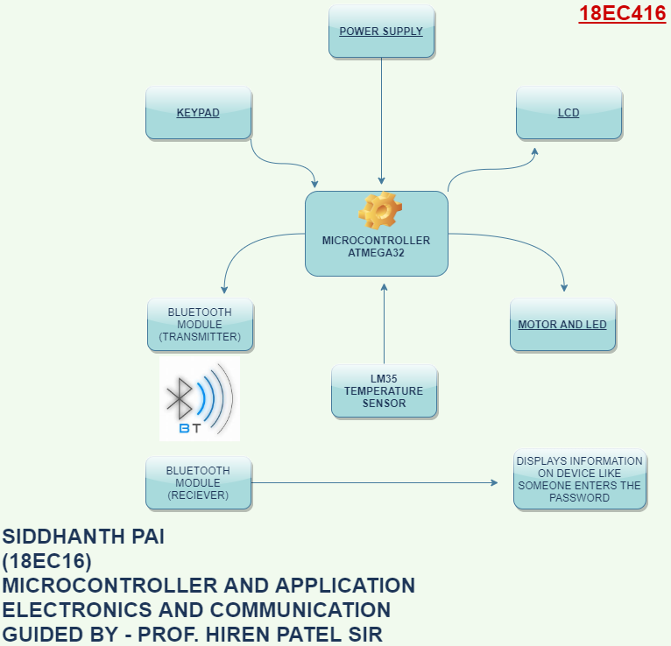

**CIRCUIT DIAGRAM:**

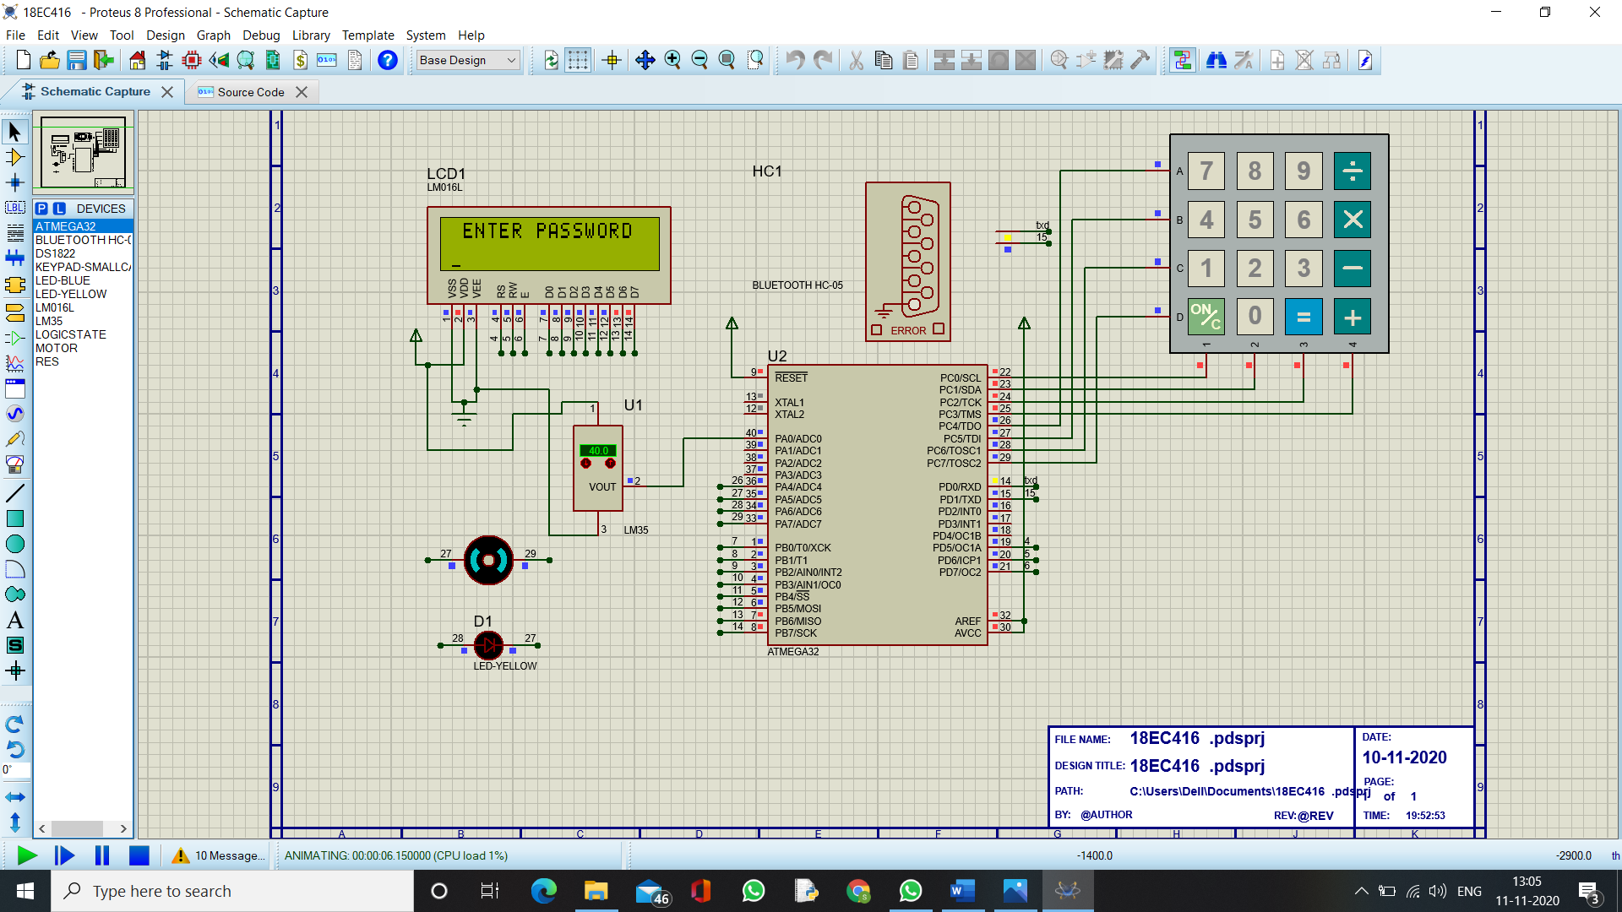

**CODE:**

#include<avr/io.h> ////////////////////////////////////// **CORRECT PASSWORD = 5678** ///////////////////////////////////////////////

#include<util/delay.h>

///////////////////////////////////////// **LCD PART** ///////////////////////////////////////////////////////////////////////

#define LCD_BPRT PORTB //FOR DATA PORT A

#define LCD_BDDR DDRB

#define LCD_BPIN PINB

#define LCD_CPRT PORTD //FOR COMANDS PORT B

#define LCD_CDDR DDRD

#define LCD_CPIN PIND

#define LCD_RS 5 /* Define Register Select (data/command reg.)pin */

#define LCD_RW 6 /* Define Read/Write signal pin */

#define LCD_EN 7 /* Define Enable signal pin */

#define KEY_PRT PORTC //initializing keyboard PORT

#define KEY_DDR DDRC //initializing keyboard DDR

#define KEY_PIN PINC //initializing keyboard PIN

void lcd_cmd(unsigned char cmnd)

{

LCD_BPRT= cmnd; // PORTB = cmnd

LCD_CPRT &= ~(1<<LCD_RS); /* RS=0 command reg. */ // RS=0 for command

LCD_CPRT &= ~(1<<LCD_RW); /* RW=0 Write operation */

LCD_CPRT |= (1<<LCD_EN); /* Enable pulse high*/

_delay_us(1);

LCD_CPRT &= ~(1<<LCD_EN); // enable low pulse

_delay_us(100);

}

void lcd_data(unsigned char cmnd)

{

LCD_BPRT= cmnd; // PORTB = cmnd

LCD_CPRT |= (1<<LCD_RS); /* RS=1 for data. */

LCD_CPRT &= ~(1<<LCD_RW); /* RW=0 Write operation */

LCD_CPRT |= (1<<LCD_EN); /* Enable pulse */

_delay_us(1);

LCD_CPRT &= ~(1<<LCD_EN);

_delay_us(100);

}

void ini_lcd(void) /* LCD Initialize function */

{

LCD_CDDR = 0xFF; /* Make LCD command port direction as o/p */

LCD_BDDR = 0xFF; /* Make LCD data port direction as o/p */

LCD_CPRT &=~(1<<LCD_EN); // enable low

_delay_us(2000); /* LCD Power ON delay always >15ms */

lcd_cmd(0x38); /* Initialization of 16X2 LCD in 8bit mode */ //00111000

lcd_cmd(0x0E); /* Display ON Cursor OFF */ //00001110

lcd_cmd(0x06); /* Auto Increment cursor */ //00000110

lcd_cmd(0x01); /* Clear display */ //00000001

lcd_cmd(0x80); /* Cursor at home position */

}

void lcd_print(char *str)

{

unsigned char i = 0;

while(str[i] != 0)

{

lcd_data(str[i]);

i++;

}

}

//////////////////////////////////////////////// **KEYPAD PART** ///////////////////////////////////////////////////////////////////////////

#define key_port PORTC

#define key_ddr DDRC

#define key_pin PINC

unsigned char keypad[4][4]= {{'7','8','9','/'},

{'4','5','6','*'},

{'1','2','3','-'},

{'c','0','=','+'}};

char takekey()

{

unsigned char row,colum;

char key;

key_ddr=0xf0; //11110000

key_port=0xff; //11111111

do

{

key_port&=0x0f; //PORTA 00001111

colum=(key_pin&0x0f); //PIN 00001111

}while(colum!=0x0f); //COLUN 00001111

do

{

do

{

_delay_ms(1);

key_port&=0x0f;

colum=(key_pin&0x0f);

}while(colum==0x0f);

_delay_ms(1);

key_port&=0x0f;

colum=(key_pin&0x0f);

}while(colum==0x0f);

while(1)

{

key_port=0xef;

colum=(key_pin&0x0f);

if(colum!=0x0f)

{

row=0;

break;

}

key_port=0xdf;

colum=(key_pin&0x0f);

if(colum!=0x0f)

{

row=1;

break;

}

key_port=0xbf;

colum=(key_pin&0x0f);

if(colum!=0x0f)

{

row=2;

break;

}

key_port=0x7f;

colum=(key_pin&0x0f);

row=3;

break;

}

if(colum==0x0e)

key=keypad[row][0];

else if(colum==0x0d)

key=keypad[row][1];

else if(colum==0x0b)

key=keypad[row][2];

else

key=keypad[row][3];

return(key);

}

//////////////////////////////////// **HC05 PART** //////////////////////////////////////////////////////////////////////////////////////

void USART_Init(unsigned long BAUDRATE) /* USART initialize function */

{

UCSRB |= (1<<RXEN)|(1<<TXEN)|(1<<RXCIE);

UCSRB &= ~(1<<UCSZ1);

UCSRC |= (1<<UCSZ0) | (1<<UCSZ1);

UCSRA |= (1<<U2X);

UBRRL = 12;

UBRRH = 0; /* Load UBRRH with upper 8 bit of prescale value */

}

char USART_RxChar() /* Data receiving function */

{

while (!(UCSRA & (1 << RXC))); /* Wait until new data receive */

return(UDR); /* Get and return received data */

}

void USART_TxChar(char data) /* Data transmitting function */

{

UDR = data; /* Write data to be transmitting in UDR */

while (!(UCSRA & (1<<UDRE))); /* Wait until data transmit and buffer get empty */

}

void USART_SendString(char *str) /* Send string of USART data function */

{

int i=0;

while (str[i]!=0)

{

USART_TxChar(str[i]); /* Send each char of string till the NULL */

i++;

}

}

///////////////////////////////////////////////////////////////////////////////////////////////////////////////////////////////////////////////////////////////////////////////////

void adc_init()

{

ADMUX = (1<<REFS0);

ADCSRA = (1<<ADEN)|(1<<ADPS2)|(1<<ADPS1)|(1<<ADPS0);

}

uint16_t adc_read(uint8_t ch)

{

ch &= 0b00000111; // AND operation with 7

ADMUX = (ADMUX & 0xF8)|ch;

ADCSRA |= (1<<ADSC);

while(ADCSRA & (1<<ADSC));

return (ADC);

}

/////////////////////////////////////// **INT MAIN** ///////////////////////////////////////////////////////////////////////////////////////////////////////////////////////

int main()

{

uint16_t adc_result0;

int temp;

adc_init();

char buffer[10];

unsigned int pass=5678,key;

unsigned char ch=0,i,w[]=" WRONG PASSWORD",E[]=" ENTER PASSWORD",s[]="CORRECT PASSWORD",a[]=" WELCOME :) ";

DDRA=0XFF;

DDRB=0XFF;

_delay_ms(500);

ini_lcd();

lcd_cmd(0x80);

for(i=0;i<15;i++)

lcd_data(a[i]);

_delay_ms(1000);

lcd_cmd(0x01);

while (1)

{

key=0; // for storing full password

ch=0; // for storing individial value of key press

lcd_cmd(0X80); //force cursor to beginning of 1st line

for(i=0;i<15;i++)

lcd_data(E[i]); // displays ENTER PASSWORD on first line

lcd_cmd(0XC0); //force cursor to beinning of 2nfdline

while(ch!='=') //get password from visitor i.e takes value , = is for going to next value

{

ch=takekey(); //takes integer one by one from user

if(ch!='=') // pressed key should not be = or else it will go to next frame for saying the password is correct or not

{

lcd_data(ch);

key=((key*10)+(ch-0x30)); //key like 5678 converting it into BCD

}

}

lcd_cmd(0X01); //clear display screen for going to next frame for saying if password is correct or not

if(key!=pass) //wrong password

{

for(i=0;i<15;i++)

lcd_data(w[i]);

PORTA=0b11110000;

USART_Init(9600); /* initialize USART with 9600 baud rate */

UBRRL = 12;

_delay_ms(500);

USART_SendString(" someone enters wrong password ");

adc_result0 = adc_read(0);

temp=adc_result0/2.01;

itoa(temp,buffer,10);

lcd_cmd(0XC0);

lcd_print("Temp=");

lcd_cmd(0xC7);

lcd_print(buffer);

lcd_cmd(0xC9);

lcd_print("C");

_delay_ms(900);

lcd_cmd(0x01);

//_delay_ms(5000);

ch=takekey(); // if not then it will come back to enter password terminal automatically

}

else //correct password

{

PORTA=0b11001100;

USART_Init(9600); /* initialize USART with 9600 baud rate */

UBRRL = 12;

_delay_ms(500);

USART_SendString(" someone has been entered");

for(i=0;i<15;i++)

{

lcd_data(s[i]);

}

adc_result0 = adc_read(0);

temp=adc_result0/2.01;

itoa(temp,buffer,10);

lcd_cmd(0XC0);

lcd_print("Temp=");

lcd_cmd(0xC7);

lcd_print(buffer);

lcd_cmd(0xC9);

lcd_print("C");

ch=takekey(); // if not then it will come back to enter password terminal automatically

PORTA=0; // to stop motor and led

lcd_cmd(0x01);

}

}

return(0);

}

**SOME OF SCREEN SHOTS:**

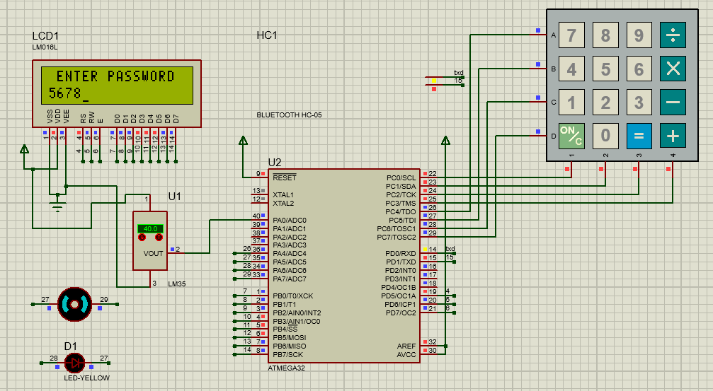

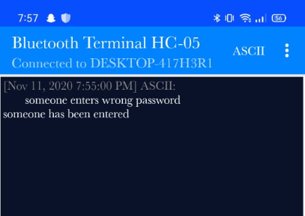

**Video link:**

